**SPRINT DELIVERY 4**

**TEAM ID: PNT2022TMID30774**

**MIT APP INVENTOR**

**HOME SCREEN:**

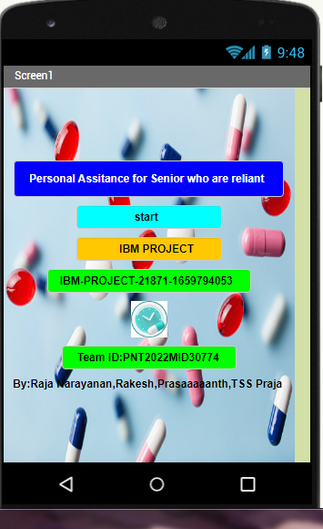

**LOG IN SCREEN:**

1. Enter the details(username and password) then press signup button. It will store the details in firebase db.
2. Enter the details(username and password) then press signup button. It will store the details in firebase db.
3. Then login with same details.

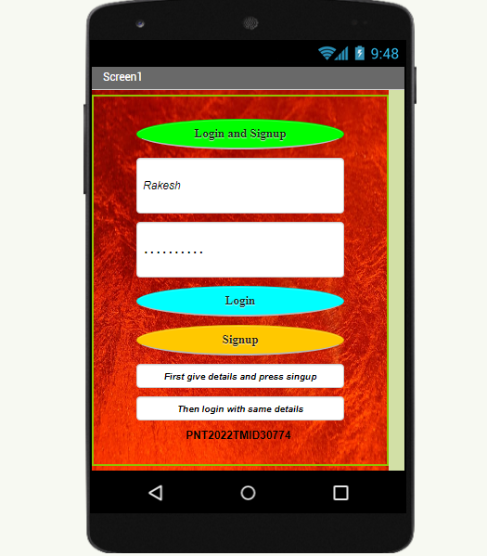

**Data stored in firebase db:**

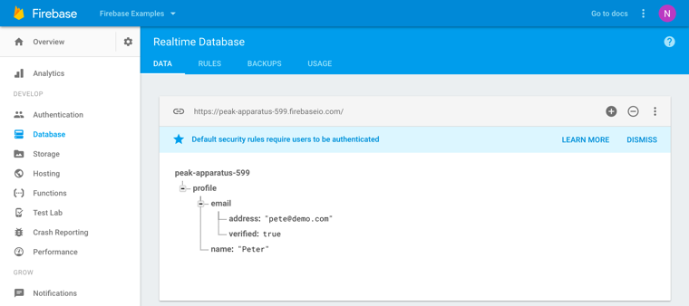

**HOME SCREEN:**

**CONTENTS:**

* 1. SET REMAINDER
  2. HEALTH INFO
  3. BUY MEDICINES
  4. ASSISTANT
  5. CHAT WITH CARETAKER
  6. CALL AND SHARE MESSAGE

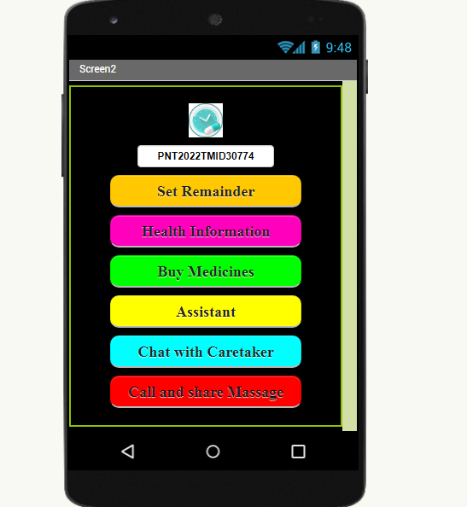

**REMINDER:**

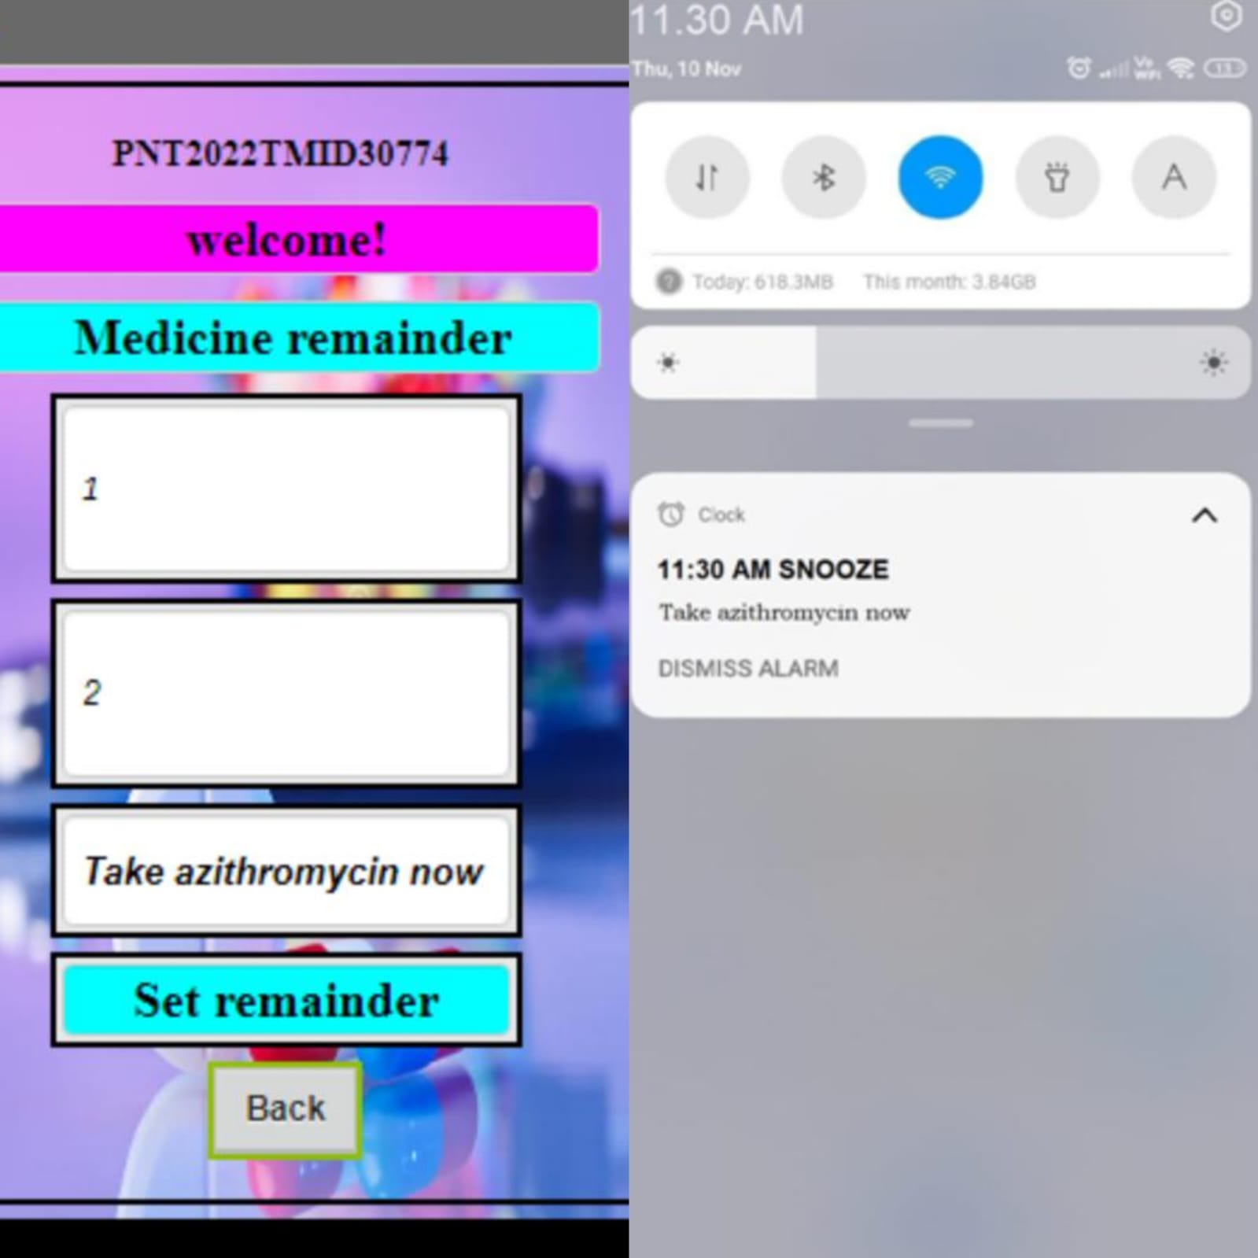

**HEALTH INFORMATION:**





**BUY MEDICINES:**

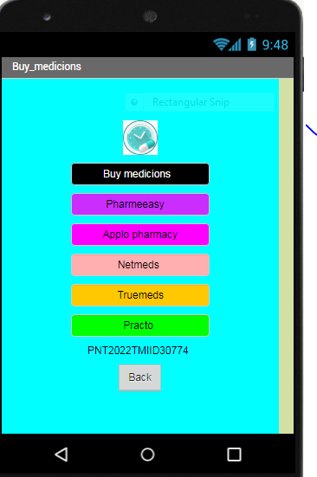

**ASSISTANT:**

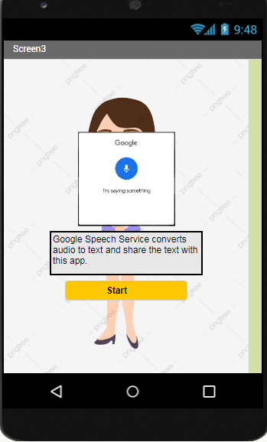

**CHAT WITH CARETAKER:**

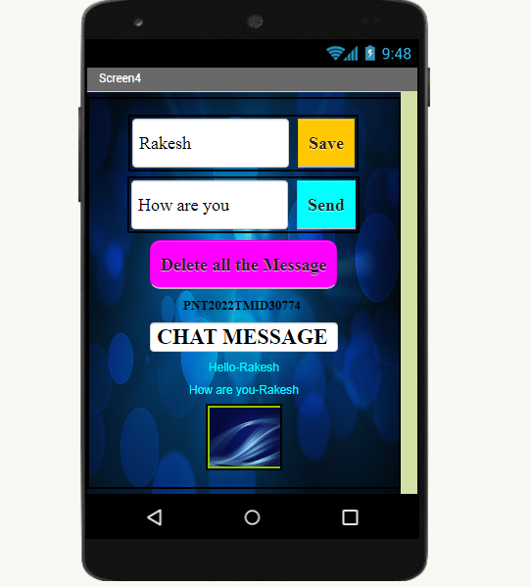

**CALL AND SHARE MESSAGE:**

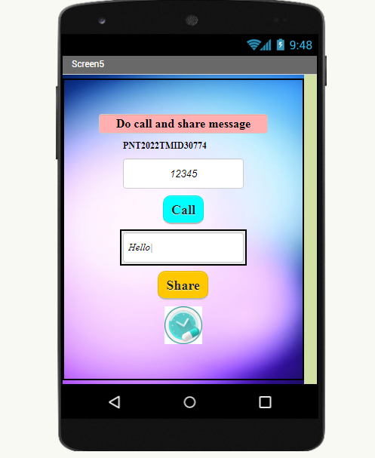

**BLOCKS:**

